**Student Result Management System**

**Bachelor of Technology**

**Computer Science and Engineering**

Submitted By

ARKAPRATIM GHOSH (13000121058)

SEPTEMBER 2023



**Techno Main Salt Lake**

**EM-4/1, Sector-V**

**Kolkata- 700091**

**West Bengal**

**India**

**Table of Contents**

Software Project Management Plan for “Student Result Management System” 3

1. Introduction 3

I. Project Overview 3

II. Project Deliverables 3

III. Evolution of this document 4

IV. References 4

V. Definitions, Acronyms, and Abbreviations 4

2. Project Organization 5

I. Process Model 5

II. Organizational Structure 6

III. Organizational Boundaries and Interfaces 6

IV. Project Responsibilities 6

3. Managerial Process 7

I. Management Objectives and Priorities 7

II. Assumptions, Dependencies, and Constraints 7

III. Risk Management 8

IV. Monitoring and Controlling Mechanisms 9

4. Technical Process 9

I. Methods, Tools, and Techniques 9

II. Software Documentation 9

III. Project Support Functions 9

5. Work Elements, Schedule, and Budget 9

6. Conclusion 10

7. References 10

# Software Project Management Plan for “Student Result Management System”

# Introduction

The Student Result Management System is a specialized software solution designed to streamline and enhance the process of managing student academic outcomes within educational institutions. This system plays a pivotal role in modernizing and automating the traditionally complex and time-consuming task of result management. By leveraging advanced technology, the Student Result Management System offers educational institutions an efficient and organized approach to recording, calculating, and disseminating student grades and academic performance. With its user-friendly interface and comprehensive features, the system aims to improve accuracy, reduce administrative burden, and provide timely access to crucial academic information for both educators and students. Through the effective implementation of the Student Result Management System, educational institutions can embrace a more effective and transparent method of result management that ultimately contributes to an enriched learning environment.

## Project Overview

The Student Result Management System project is initiated with the aim of revolutionizing the way academic outcomes are handled within educational institutions. The purpose of this project is to develop an advanced software solution that automates and simplifies the process of managing student results, from recording grades to generating comprehensive transcripts. The scope encompasses the design, development, testing, and implementation of a user-friendly platform that caters to both educators and students, facilitating seamless interaction with academic data. The key objectives include enhancing accuracy in result computation, reducing administrative overhead, and providing real-time access to academic performance records. The project strives to empower educators with efficient tools for result entry and analysis while granting students the ability to easily track their progress. Stakeholders, including academic staff, students, administrators, and parents, have distinct roles: academic staff manage grades, students monitor their performance, administrators oversee system functionality, and parents gain insights into their child's progress. The Student Result Management System will feature functionalities such as result entry, automated grade calculations, transcript generation, and data security measures. These high-level features aim to create a centralized hub for all result-related activities, fostering an environment of transparency, accuracy, and effective communication within the educational institution.

## Project Deliverables

1. Preliminary Project Plan 11.08.2023

2. Requirements Specification 18.08.2023

3. Analysis [Object model, Dynamic model, and User interface] 01.09.2023

4. Architecture Specification 15.09.2023

5. Component/Object Specification 29.09.2023

6. Source Code 20.10.2023 - 16.11.2023

7. Test Plan 17.11.2023 - 21.11.2023

8. Final Product Demo 22.11.2023 - 22.11.2023

## Evolution of this document

This document will be updated as the project progresses. Updates should be expected in the following sections:

1. ***References*** - updated as necessary.
2. ***Definitions, acronyms, and abbreviations*** - updated as necessary.
3. ***Organizational Structure*** will be updated as the team leaders are assigned for each phase.
4. ***Technical Process -*** this section will be revised appropriately as the requirements and design decisions become clearer.
5. ***Schedule –*** as the project progresses, the schedule will be updated accordingly.

**Revision History**

| **Revision** | **Date** | **Updated By** | **Update Comments** |
| --- | --- | --- | --- |
| 0.1 | 08.08.2023 | Arkapratim Ghosh | First Draft |

## References

* + 1. Team Website <https://drive.google.com/drive/folders/1UeCyaGTVO7-hYQ_8FrFHm4Z7dbwxLFks?usp=drive_link>
    2. Project Scope <https://drive.google.com/drive/folders/1UeCyaGTVO7-hYQ_8FrFHm4Z7dbwxLFks?usp=drive_link>

Case Studies

* [Student Result Management System - Peer-reviewed Journal (ijarcce.com)](https://ijarcce.com/papers/student-result-management-system/)
* [(PDF) Web-Based Student Result Management System (researchgate.net)](https://www.researchgate.net/publication/318215858_Web-Based_Student_Result_Management_System)

## Definitions, Acronyms, and Abbreviations

1. SRS: Software Requirements Specification
2. SPMP: Software Project Management Plan
3. DFD: Data Flow Diagram
4. FPM: Function Point Measurement
5. GUI: Graphical User Interface
6. DBMS: Database Management System
7. API: Application Programming Interface
8. UI: User Interface
9. QA: Quality Assurance
10. DBA: Database Administrator
11. IDD: Interface Design Document
12. TDD: Test-Driven Development
13. OOP: Object-Oriented Programming
14. DSDM: Dynamic Systems Development Method
15. SSD: System Specification Document

# Project Organization

## Process Model

For this project, we have chosen the Iterative Waterfall Model as our development process. In this model, each stage allows us to conduct testing after the completion of a phase, facilitating a structured approach to development and testing. Unlike the traditional Waterfall Model, which strictly follows a linear sequence, the Iterative Waterfall Model incorporates iterations and feedback loops at key stages of the project. At the heart of this approach is the idea that each phase, such as requirements gathering, design, implementation, and testing, can be revisited and refined iteratively. This means that after the initial completion of a phase, we can circle back to it based on feedback and changing requirements, allowing us to make necessary adjustments and improvements.This iterative approach enhances flexibility and adaptability, which is particularly beneficial for a student result management system. By continuously gathering feedback from stakeholders, including students, teachers, and administrators, we can ensure that the system evolves to meet their evolving needs and expectations. This ongoing feedback loop and iterative refinement process are integral to delivering a system that aligns with the dynamic nature of educational institutions.

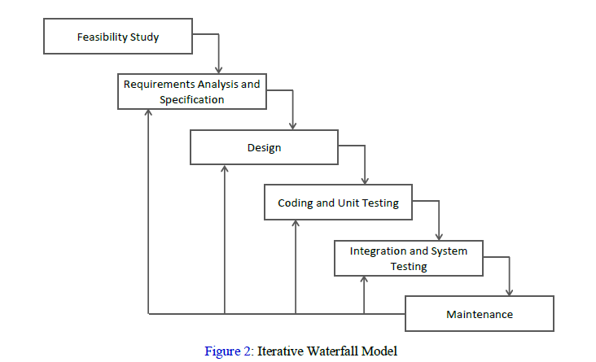

## Organizational Structure

Team Members –

1. Arkapratim Ghosh

| **Name** | **Organization/**  **Position** | **Contact Information** |
| --- | --- | --- |
| Arkapratim Ghosh | APG Project Manager | [arkapratimghosh1264@gmail.com](mailto:arkapratimghosh1264@gmail.com)  9330450430 |

| **Days** | **Deliverable** | **Team Leader** | **Deliverable Description** |
| --- | --- | --- | --- |
| 5 | 1 | Arkapratim Ghosh | Project Plan |
| 10 | 2 | Arkapratim Ghosh | Requirements Specification |
| 10 | 3 | Arkapratim Ghosh | Analysis |
| 10 | 4 | Arkapratim Ghosh | Architecture Specification |
| 15 | 5 | Arkapratim Ghosh | Component/Object Specification |
| 20 | 6 | Arkapratim Ghosh | Source Code |
| 14 | 7 | Arkapratim Ghosh | Test Plan |
| 0 | 8 | Arkapratim Ghosh | Final Deliverable |

## Organizational Boundaries and Interfaces

Team leaders throughout each development of the phases will be responsible for coordinating team meetings, updates, communications, and team deliverables.

## Project Responsibilities

For the most vital responsibilities per phase of each team members, please refer to segment 2.2. Ultimately the project team is responsible for the successful delivery of the product. The team member tasks per deliverable according to expertise and the phases are as given below:

1. Project Plan – Whole Team
2. Requirements Specification – TBD
3. Analysis – TBD
4. Architecture Specification – TBD
5. Component/Object Specification – TBD
6. Source Code – TBD
7. Test Plan – TBD
8. Final Deliverable – Entire Team

| **Name** | **Organization/**  **Position** | **Role/Responsibilities** |
| --- | --- | --- |
| Arkapratim Ghosh | APG Project Manager | * Managing and leading the project team. * Developing and maintaining a detailed project plan. * Monitoring project progress and performance. * Managing project evaluation and dissemination activities. * Develop corrective actions when necessary. |
| Arkapratim Ghosh | APG Business Analyst | * Prepare reports on project plans, status, progress, risks, deadlines and resource requirements. * Develop and perform work flow analysis to find out the difficulties in reaching goals. * Provide project cost estimates. |
| Arkapratim Ghosh | APG Designer | * Propose effective design solutions to meet project goals. * Prepare design layouts and sketches according to company design standards. * Keeping of records and files. |
| Arkapratim Ghosh | APG Staff | * Documentation of daily activities. * Making kick-off meeting reports. * In-charge of materials needed for team building activities. |

# Managerial Process

## Management Objectives and Priorities

The management objective is to deliver the product in time and of high quality. The PM and QAM work together to achieve this by respectively checking that progress is made as planned and monitoring the quality of the product at various stages.

## Assumptions, Dependencies, and Constraints

In this project plan, a number of factors are taken into account. The following list shows the way milestones on various project phases have been scheduled:

• The team budget of 1-person x 365 hours = 365 hours

• The project deadline of December 18th.

• The final presentation is on December 19th.

• The peer evaluation deadline is on December 18th.

• Other days the weekends holiday is closed (August 13th, August 20th, August 27th, September 3rd, September 10th, September 17th, September 24th, October 1st, October 8th, October 15th, October 22nd, October 29th, November 5th, November 12th , November 19th, November 26th, December 3rd, December 10th, December 17th).

NOTE: Due to the deadline of 18th December 2023, running out of time will have its reflection on the product, and not on the duration of the project. By assigning a priority to every user requirement, a selection can be made of user requirements that may be dropped out if time runs out.

## Risk Management

Identify Risks:

* Data Security Concerns: Consider the risk of unauthorized access to sensitive student data. Without proper security measures, data breaches could occur.
* Technical Challenges: As the sole developer, you might face technical obstacles or limitations that could impact the project's progress or quality.
* Time Constraints: Given your limited resources, there's a risk that the project might take longer to complete than initially estimated.
* Scope Creep: The project's scope might expand beyond your initial plan, affecting timelines and overall project management.
* Lack of Expertise: Certain areas, such as UI/UX design or database optimization, might be outside your expertise, leading to suboptimal solutions.

**Assess Risks**:

Rank the identified risks based on their potential impact and likelihood of occurrence. Focus on risks that have a higher chance of negatively affecting your project.

**Mitigation Strategies:**

* Data Security: Implement strong authentication mechanisms and encryption to protect student data. Regularly update security patches and consider penetration testing.
* Technical Challenges: Break down the project into smaller, manageable tasks. Research and learn about unfamiliar technologies or concepts as needed.
* Time Constraints: Set realistic timelines and prioritize tasks. Regularly review your progress and adjust timelines if necessary.
* Scope Creep: Clearly define project scope and objectives. Resist adding features that are not essential to the core functionality.
* Lack of Expertise: Leverage online resources, tutorials, and communities to gain knowledge in areas where you're less experienced. Consider seeking advice from peers.

Have a backup plan for critical risks. For instance, if a technical challenge proves insurmountable, be prepared to pivot or seek external assistance.

Maintain open communication with stakeholders, explaining potential delays or challenges and discussing possible solutions. Keep detailed documentation of your risk assessment, strategies, and any changes made. This documentation can be invaluable for future projects. Regularly test your system as you develop it. This can help identify technical challenges or bugs early, minimizing their impact on the project timeline.

## Monitoring and Controlling Mechanisms

The monitoring of progress is done by the PM using the following means:

1. Weekly project status meetings
2. Shared document repository
3. Project tracking by MS project plan
4. Tracking utilizing baselines in MS project

# Technical Process

## Methods, Tools, and Techniques

The project will be implemented utilizing V-model methodology, and tools such as Microsoft Project, Star UML, PHP, HTML, CSS, JavaScript MySQL will be utilized. The risks for each category are listed to complete the project successfully.

## Software Documentation

Documentation such as Functional Specification document, Technical Specification document and Detail Design Document.

## Project Support Functions

All project support documents will be completed in applicable phases.

# Work Elements, Schedule, and Budget

* + The project is accounted for project resources, technologies and tools required to whole analysis, implementation, and test of the application.
  + The document for all phases will be revised in subsequent phases if applicable.

Budget and Resource Allocation

Salary 170,000.00

Office Operations/Supplies/Equipment/Consumables 40,000.00

Miscellaneous 10,000.00

**Total**  **Rs. 220,000.00**

**Schedule**

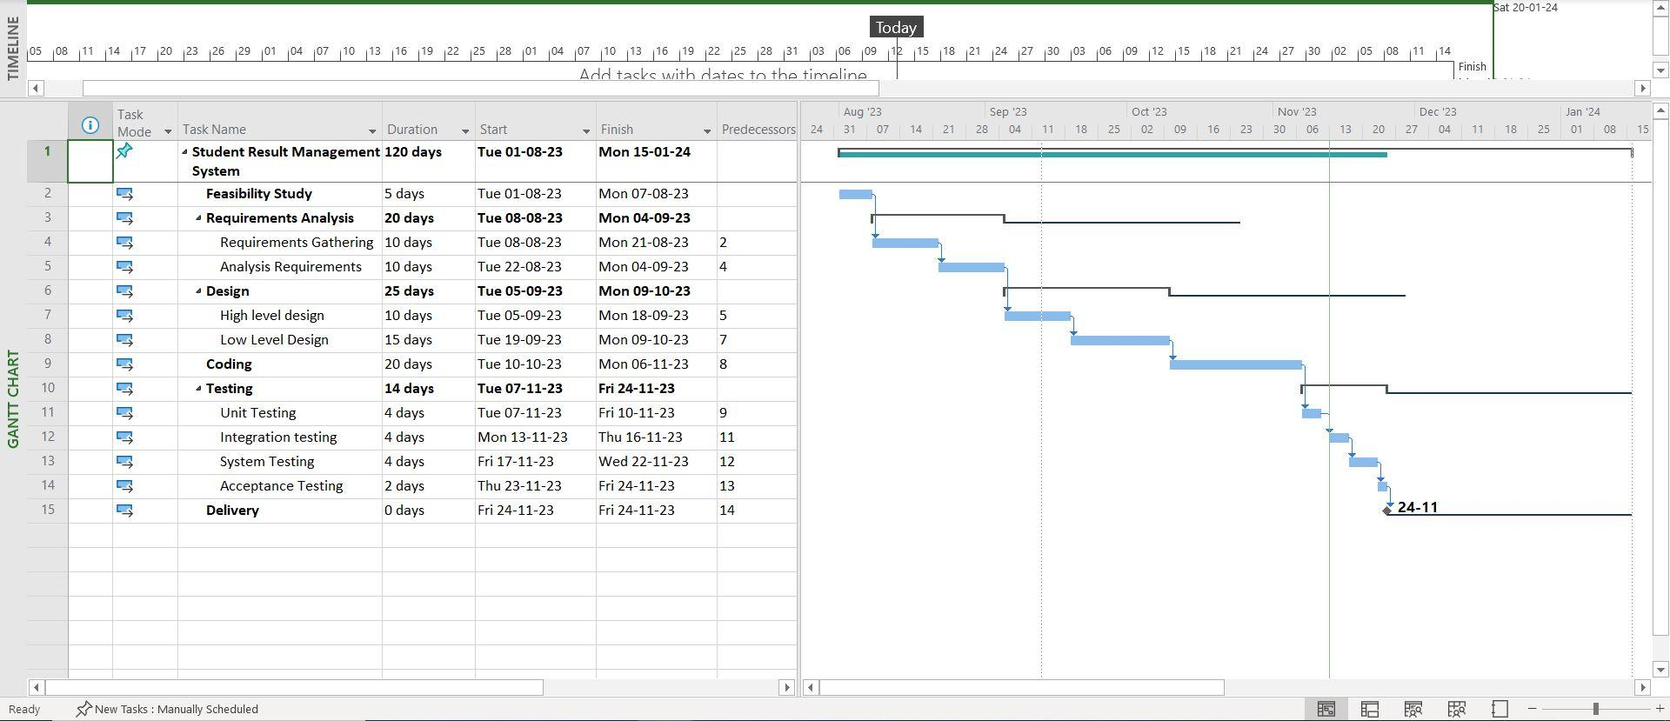

# Conclusion

In conclusion, the development and management of the Student Result Management System is a complex yet essential endeavor for our educational institution. This Software Project Management Plan has provided a comprehensive roadmap for successfully executing this project. Throughout this SPMP, we have outlined the project's objectives, scope, stakeholders, requirements, schedule, and resources. We have also defined roles and responsibilities, risk management strategies, and quality assurance measures.

# References

* [What is Student Result Management System? Advantage & Disadvantage (edusys.co)](https://www.edusys.co/blog/student-result-management-system)
* [Student Result Management system in php | Student Result Management Project (phpgurukul.com)](https://phpgurukul.com/student-result-management-system/)
* [Result Management System by codervex | CodeCanyon](https://codecanyon.net/item/result-management-system/22462424)